  - NHS Equality Delivery System 2022

EDS Report 2024
Version 1, 15 August 2022

Classification: Official
Publication approval reference:

Contents
Equality Delivery System for the NHS 2

Equality Delivery System for the NHS
The EDS Reporting Template

Implementation of the Equality Delivery System (EDS) is a requirement on both NHS commissioners and NHS providers. Organisations are encouraged to follow the implementation of EDS in accordance EDS guidance documents. The documents can be found at: www.england.nhs.uk/about/equality/equality-hub/patient-equalities-programme/equality-frameworks-and-information-standards/eds/
The EDS is an improvement tool for patients, staff and leaders of the NHS. It supports NHS organisations in England - in active conversations with patients, public, staff, staff networks, community groups and trade unions - to review and develop their approach in addressing health inequalities through three domains: Services, Workforce and Leadership. It is driven by data, evidence, engagement and insight.
The EDS Report is a template which is designed to give an overview of the organisation’s most recent EDS implementation and grade. Once completed, the report should be submitted via england.eandhi@nhs.net and published on the organisation’s website.

Name of Organisation |  | York and Scarborough Teaching Hospitals NHS Foundation Trust | Organisation Board Sponsor/Lead
 |  |  | Director of Workforce and Organisational Development
Name of Integrated Care System |  | Humber and North Yorkshire Health and Care Partnership

NHS Equality Delivery System (EDS)

EDS Lead | Head of Equality, Diversity and Inclusion |  | At what level has this been completed?
 |  |  |  | *List organisations
EDS engagement date(s) | Domain 1, 6 December 2023 Tobacco Dependency Service.  Domain 1, 22 February 2024, Learning Disability Liaison Service.  Domain 1, 27 February 2024, Community Palliative Care.  Domain 2,13 December 2023  Domain 3, 23 January 2024 |  | Individual organisation | York and Scarborough Teaching Hospitals
 |  |  | Partnership* (two or more organisations) | Peer Reviewer for Domain 3, Harrogate and District NHS Foundation Trust
 |  |  | Integrated Care System-wide*

Date completed | February 2024 | Month and year published | February 2024
Date authorised | 28 February 2024 | Revision date | February 2025

Completed actions from previous year
Action/activity | Related equality objectives
Domain 1  Maternity Service  - Build links with local community groups including the Maternity and Neonatal Voices Partnership – this work is ongoing but a strong partnership has developed with the new Partnership chair and patient engagement activities are planned for winter 2023 and beyond.  Interpretation and Translation Services  The assessment rated the service developing and identified several actions.  Activity on the actions included:  Activity 1 - Continue work to improve and sustain performance:  - Sustain fill rates to meet patient needs, including BSL and refugee languages. As a result of regular contract management meetings, fill rates continued to improve throughout the period. They have moved from 68.2% in July 2022 to 95.7% in Q3 2023 with consistent improvements throughout the period.  - Continue review meetings, review complaints / concerns. This moved to monthly meetings autumn 2023 as a result of improved performance.  - Monitor usage of video interpreting tablet devices – this is ongoing and challenges regarding changes to the language interpreting app are being addressed on a regular basis.  - Implement BSL Relay service – this was implemented in April 2023.  Activity 2 - Influence procurement approach to support people’s needs  - Ensure BSL fill rates and face to face provision are specifically considered – these are raised at every contract management meeting and are regularly monitored.  - Propose patient involvement and BSL provision are considered – these have been suggested to include in the tender for a new service provider.  - Propose patient feedback mechanisms are built into future contract – these have been recommended.  - Develop new tender for interpreting services, exploring a joint approach – this is ongoing with work being led by North Lincolnshire and Goole NHS Foundation Trust. It also includes Hull University Teaching Hospitals NHS Trust.  Activity 3 - Plan for future patient involvement  - Approach local stakeholders to support EDS scoring exercise – this was done and continues to happen.  - Explore how to involve and receive feedback from people who use interpreting services (and groups who represent them), as our patient involvement activity develops, including survey data and future / repeat EDS review after the procurement exercise e.g., in 2024 – activity has included engaging with sight loss organisations, York Deaf Café members and local Healthwatch. | Public Sector Equality Duty (PSED)  Objective 1  To engage with patients, carers, Trust Governors and local stakeholders and organisations, (including CCGs, social care, Healthwatch) to listen and understand the needs of our patients  Objective 2  To engage internally with services to discuss how the needs of patients can be met to ensure that:  - health inequalities are reduced  - discrimination is eliminated  - patients and staff are provided with appropriate tools.
Domain 2, N/A in 2023
Domain 3, N/A in 2023

EDS Rating and Score Card

Please refer to the Rating and Score Card supporting guidance document before you start to score. The Rating and Score Card supporting guidance document has a full explanation of the new rating procedure, and can assist you and those you are engaging with to ensure rating is done correctly

Score each outcome. Add the scores of all outcomes together. This will provide you with your overall score, or your EDS Organisation Rating. Ratings in accordance to scores are below
Undeveloped activity – organisations score out of 0 for each outcome | Those who score under 8, adding all outcome scores in all domains, are rated Undeveloped
Developing activity – organisations score out of 1 for each outcome | Those who score between 8 and 21, adding all outcome scores in all domains, are rated Developing
Achieving activity – organisations score out of 2 for each outcome | Those who score between 22 and 32, adding all outcome scores in all domains, are rated Achieving
Excelling activity – organisations score out of 3 for each outcome | Those who score 33, adding all outcome scores in all domains, are rated Excelling

Domain 1: Commissioned or provided services

Domain | Outcome | Evidence | Rating | Owner (Dept/Lead)
Domain 1: Commissioned or provided services | 1A: Patients (service users) have required levels of access to the service | Tobacco Dependency Service  Service data identifies the ethnicity, disability status, gender and deprivation of the patient cohort who are all Trust inpatients. At the time of the event, we were not able to compare this data to Trust patient cohort data.  Issues in data recording at a Trust and service level were noted as information about smoking status, religion, sexuality, other language and other health inequality information was not currently recorded.  Trust interpreting services are available to the Tobacco Dependency Advisers and they had created Plain English service information.  Learning Disability Liaison Service  Compared to the Trust’s demographic profile, the service supports more men than women. As it is an adults-only service (apart from complex cases for young people) the age profile is different. The ethnicity profile is similar and the service works with people with a range of physical disabilities as well as learning disabilities. There is no health inequalities data for service users.  The service provides information in Easy Read and accesses the Trust’s interpreting and translation services as needed.  Changing Places facilities are available at Scarborough and York Hospitals and quiet waiting rooms are being developed at both emergency departments.  Community Palliative Care Service  Service data shows a similar demographic profile to Trust data – apart from the age profile where the service understandably has an older age profile. The service also works with GP data, which records more demographic information, to understand patient needs including disability and health inequalities.  The service works with all patients referred (unless another service is more appropriate) including some who haven’t engaged with any other health service before.  It supports people with benefits claims, grants and more to enable people to meet all needs and often works with people experiencing health inequalities for a wide variety of reasons.  The service cares for illiterate people and speakers of other languages.  Examples given include supporting members of the traveller community, homeless people, barge residents, Muslim patients and prisoners. | 1 Developing  2 Achieving  3 – Excelling | Tobacco Dependency Service  Learning Disability Liaison Service  Community Palliative Care Service
 | 1B: Individual patients (service users) health needs are met | Tobacco Dependency Service  Trust EDI processes and policies support the team, including interpreting and translation services. The team has undertaken a wide range of training linked to their direct role, Trust mandatory EDI training and have booked on to training including:  - Disability training module  - Gender Identity & Gender Diverse Communities and Transgender Awareness  - Conscious Inclusion  - Cultural Competence  - Neurodiversity in the Workplace  - Race Equality Awareness / Race & Racism Conversations at Work  - Health Coaching Programme  No complaints or concerns have been raised about the service and anecdotal feedback is all positive. While there is currently no patient feedback process in place, this is planned based on a neighbouring Trust’s approach and a Friends and Family Test is being introduced for the service.  Learning Disability Liaison Service  Staff work with service users to develop hospital passports and store them on the hospital system to ensure all hospital staff are aware of a patient’s needs and can implement reasonable adjustments as appropriate. The team, including experts by experience, also supports patients to ensure reasonable adjustments are in place and visits inpatients to identify anything they require.  The service works with colleagues to raise awareness of the needs of people with learning disabilities and provides bespoke training, online information, standard operating procedures and Easy Read resources for staff across the Trust to use to best support patients with learning disabilities.  All staff have undertaken appropriate training or are planning to, including a range of EDI training. The staff help to deliver Oliver McGowan training for colleagues and support carers to be more involved via John’s Campaign.  Staff seek regular feedback from service users and work closely with statutory and voluntary organisations to get feedback.  Community Palliative Care Service  Thorough patient social histories identify needs which are met including support for family and friends.  Support is given at home, wherever that home is, and the service has adapted to provide help on canal barges, in homeless hostels and in prison. Staff train patients, relatives and other staff to support patients to die in a place of their choosing.  The service is underpinned by processes and protocols. It offers information in any language and has produced Easy Read information.  Staff undertake all relevant training including Prevent, safeguarding and tackling racism and discrimination. | 2 Achieving  2 Achieving  3 - Excelling | Tobacco Dependency Service  Learning Disability Liaison Service  Community Palliative Care Service
 | 1C: When patients (service users) use the service, they are free from harm | Tobacco Dependency Service  The service aims to keep people safe from the risk of harm from smoking. It supports people to move to safer options or stop smoking completely.  The service supports people in the way that best supports them. It also reduces the risks of people leaving wards to go outside to smoke when this isn’t safe or appropriate for their health.  One example was given of a patient who could bleed profusely at any point, being supported to give up smoking. This meant they no longer left the ward, significantly reducing their risk.  The team abides by the Trust’s professional standards and has plans in place to learn from any complaints or concerns and from safety concerns.  The team works closely with other teams across the hospital to support their work and keep patients safe.  Possible gaps were identified:  - It can be difficult to identify patient needs particularly around reasonable adjustments – this will improve when the national reasonable adjustment flags are introduced in 2024.  - Staff may not be ready to meet patient needs at every opportunity / contact – but they are undertaking training to support them to do this.  Learning Disability Liaison Service  The service is in place to ensure patients with a learning disability are safe from harm, that their needs are met and reasonable adjustments in place.  It employs Experts by Experience to liaise with and support inpatients and works closely with the Trust’s Autism Liaison Lead and Mental Capacity Act leads.  As above hospital passports help to ensure reasonable adjustments are in place.  Engagement with people with a learning disability for the assessment found all feel safe at the hospital.  Community Palliative Care Service  The service aims to ensure patients have as good a death as possible in the place of their choosing.  As above, protocols and training support this. The team works closely with others including district nurses, hospice colleagues and safeguarding leads to ensure safety is paramount. They also train and support others to provide effective care in the appropriate environment for each person.  The service looks at holistic needs and helps people to make benefits claims, get grant funding to cover heating costs, new white goods etc as required. The service also connects patients, relatives and friends with other health and care services they may never have engaged with.  Risk assessments are regularly carried out and staff learn from any concerns, complaints, safety concerns or comments from patients, friends and family. | 2 Achieving  1 Developing  3 - Excelling | Tobacco Dependency Service  Learning Disability Liaison Service  Community Palliative Care Service
 | 1D: Patients (service users) report positive experiences of the service | Tobacco Dependency Service  There have been no complaints or concerns about the service.  The anecdotal feedback about the service is positive.  A new approach is in development to gather patient experience alongside a new Friends and Family Test card for the service.  Learning Disability Liaison Service  No concerns or complaints logged by PALS. Positive feedback was gained from engagement with people with a learning disability.  Discussion groups for service users launched successfully in January 2024. This links to a Trust professional’s steering group.  The team liaises regularly with statutory and voluntary sector organisations to get feedback about services and plans.  The service sends Easy Read feedback forms to all appropriate patients and an Easy Read Friends and Family Test card is planned.  Community Palliative Care Service  No concerns or complaints have been noted by PALS. Feedback is sought via a QR code on bereavement cards.  The service and staff receive complementary comments, cards and gifts as a result of their service.  Feedback shared is very positive. | 1 Developing  2 Achieving  2 - Achieving | Tobacco Dependency Service / Patient Experience Team  Learning Disability Liaison Service  Community Palliative Care Service
Domain 1: Commissioned or provided services overall rating |  |  | 24

Domain 2: Workforce health and well-being
Domain | Outcome | Evidence | Rating | Owner (Dept/Lead)
Domain 2:  Workforce health and well-being | 2A: When at work, staff are provided with support to manage obesity, diabetes, asthma, COPD and mental health conditions | Obesity and Diabetes  - Free access to the Step into Health course, a four-week interactive programme, encouraging individuals to take time to look at their own lifestyles and make positive changes, whilst achieving a qualification in the process.  - National week-long awareness events run throughout the year at all Trust sites, several of which target obesity:  - Know your numbers week (January) (BMI, weight, waist measurements, BP etc)  - Nutrition and Hydration week (March) (healthy nutrition and hydration info promoted)  - Be Active/On your feet Britain week (April) (the importance of activity for physical health/weight management)  - On-site gyms at Scarborough and Bridlington Hospitals  - Discounted gym memberships (Staff Benefits)  - Cycle to work scheme (Staff Benefits)  - Physical activity grant (Staff Benefits)  - Online course – Learning Curve Group (Understanding Nutrition and Health)  - Free 30-minute virtual health checks, which aim to help individuals identify and monitor areas of their health and behaviour that may affect their current and future health.  - Virtual workshops, including:  - Eat Well  - Weight Management  - Be Active  - Free access to a library of 20-30-minute activity videos, featuring a variety of free activities, including:  - Yoga and Pilates  - Stretch and unwind  - High impact aerobics  - Low impact aerobics  - Nutrition, hydration, and sleep advice  Asthma and COPD  - The Occupational Health (OH) team checks for occupational acquired asthma. They conduct health surveillance in areas where there are known respiratory sensitisers e.g., dust, fumes. They also perform lung function tests – e.g., on maintenance workers, max fax, plaster technicians.  - The team also completes a Pre-Employment Health Questionnaire (PEHQ), to discuss any allergies, and uses this information to advise line managers to ensure that that they do not expose certain individuals to known sensitisers.  - During management referrals if individuals have asthma, the OH team asks if this is currently well controlled, or gives basic advice about monitoring peak flows, and advises them to have regular annual check-ups with their GP.  - The Trust provides support for all colleagues who want to quit smoking (Tobacco Dependency Advisers).  - The OH team conducts health surveillance in areas where there are known respiratory sensitisers (e.g., dust, fumes), for specific roles that have been identified as needing this extra level of care.  - During management referrals, the OH team asks questions about the individual’s health conditions, treatment etc, and advises their line manager about adjustments needed to reduce the impact of their health condition in the workplace.  Mental health conditions  - The Trust currently has 116 trained Mental Health First Aiders (coordinated by The Wellbeing Team).  - Time 2 Talk Week (mental health focussed) (February) – all Trust sites visited.  - Mental Health Awareness Week (May) – all Trust sites visited.  - Menopause Week (strong focus on women’s mental health) (October) – all Trust sites visited.  - Men’s Health Week (strong focus on men’s mental health) (November) – all Trust sites visited.  - Wellbeing apps promoted e.g., Headspace, Unmind, Stay Alive etc.  - Menfulness (male mental health charity) promoted in the Trust.  - Employee Assistance Programme (EAP) | 1 – Developing Activity | Head of Occupational Health and Wellbeing  Head of Employee Relations & Engagement
 | 2B: When at work, staff are free from abuse, harassment, bullying and physical violence from any source | The Trust was average in comparison to other Acute and Acute and Community Trusts in relation to staff reporting negative experiences through the 2022 staff survey.  This result is made up from a number of questions:  - Promoted zero tolerance approach to bullying and harassment in 2023.  - Launch of new Civility, Respect and Resolution Policy to make it easier for staff to raise concerns.  - Launch of Just and Learning Assessment to ensure a fair process for all, everyone is accountable for their own behaviours.  - Review of the Trust’s exclusion policy and associated training to follow.  - Campaign planned for 2024 to remind patients and visitors about the Trust’s approach to violence towards staff.  - Published new Policy (Dec 2023) – Managing Violence and Aggression.  - Recruited two Safety Trainer and Educators in violence reduction, they are currently carrying out planning and prep work, obtaining licenses to deliver specific physical intervention and breakaway modules for our staff. Roll out of this training will commence in March 2024 and will be offered to all staff, with a phase 1 roll out targeting high-risk areas.  - Paper to be submitted early 2024 to recruit some non-clinical safety investigators, who will be able to give greater support to staff following an incident.  - Working with external agencies such as the Police and Crown Prosecution Service to ensure that that the ‘Assault against Emergency Workers Act 2018’ is appropriately used to prosecute individuals who subject NHS staff to violence and aggression when they are undertaking their duties.  - Area-specific violence and aggression risk assessments have been developed and are now live, allowing staff locally to see the hazards associated with violence and aggression and what the Trust is putting in place to mitigate and control any risks posed. | 0 -Underdeveloped Activity | Head of Employee Relations & Engagement  Head of Occupational Health and Wellbeing
 | 2C: Staff have access to independent support and advice when suffering from stress, abuse, bullying harassment and physical violence from any source | The Trust has a range of support available to staff:  - Union Representatives  - Freedom to Speak up Guardian.  - Fairness Champions  - Staff networks  - Chaplaincy  - Mental Health First Aiders  - Health and Wellbeing Booklet  - Psychological support  - Occupational Health and Wellbeing  - Due Regard Impact Assessments for all policies  Actions taken by the Trust in support:  - Review and relaunch of the Civility, Respect and Resolution Policy working in collaboration with trades union colleagues.  - Due Regard Impact Assessments completed through policy development.  - Development of Just and Learning Assessment.  - Staff networks invited to review and comment on any HR policy whilst it is in review/development.  - Relaunch of the Fairness Champions.  - Launch of Our Voice Our Future.  - Union representatives are independent members on CRR panels.  - Refresh of Due Regard Impact Assessments ongoing.  - Trust has signed up to the Sexual Safety at Work Charter. | 1 - Developing Activity | Head of Occupational Health and Wellbeing  Head of Employee Relations & Engagement
 | 2D: Staff recommend the organisation as a place to work and receive treatment | - WDES action planning regarding staff engagement:  - Neurodiversity at work workshop.  - Target to improve equality, diversity and human rights training to 85%.  - Continue to include disabled staff stories at Board and in Staff Matters.  - Promotion and collation of exit interview data.  - Care Groups review exit interview data.  - Exit interviews now record protected characteristics and going forward this data will be collated, shared for action planning and shared with the Council of Governors. | 0-Underdeveloped Activity | Head of Employee Relations & Engagement  Head of Occupational Health and Wellbeing
Domain 2: Workforce health and well-being overall rating |  |  | 2

Domain 3: Inclusive leadership
Domain | Outcome | Evidence | Rating | Owner (Dept/Lead)
Domain 3:  Inclusive leadership | 3A: Board members, system leaders (Band 9 and VSM) and those with line management responsibilities routinely demonstrate their understanding of, and commitment to, equality and health inequalities | 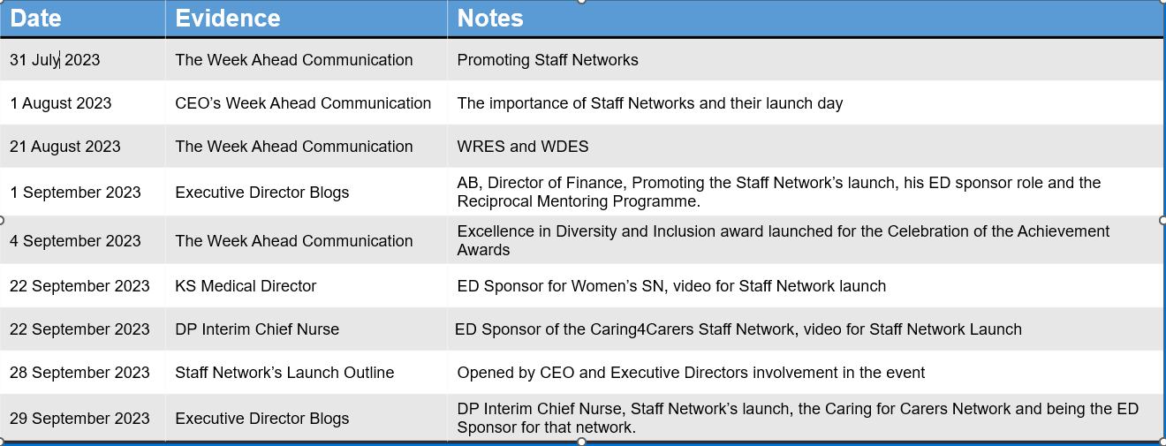  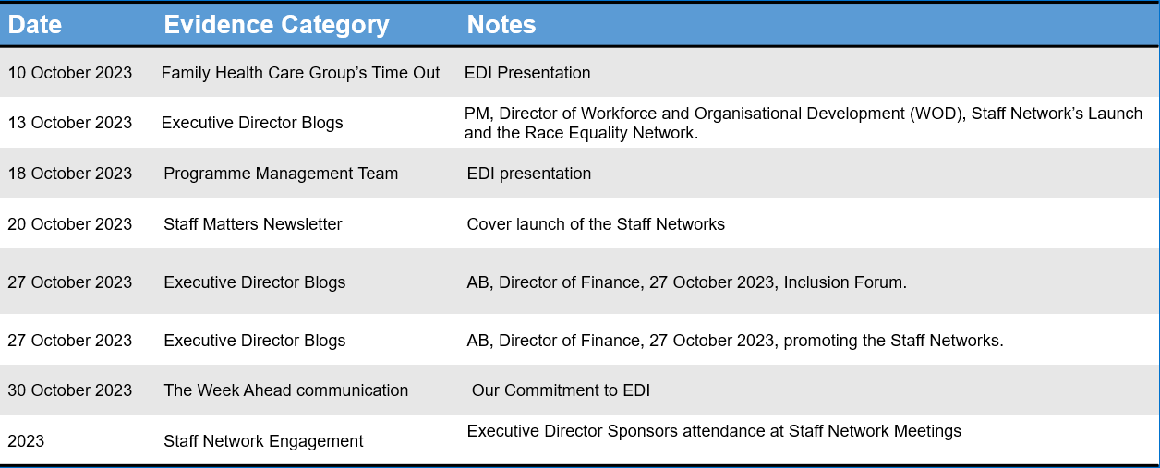  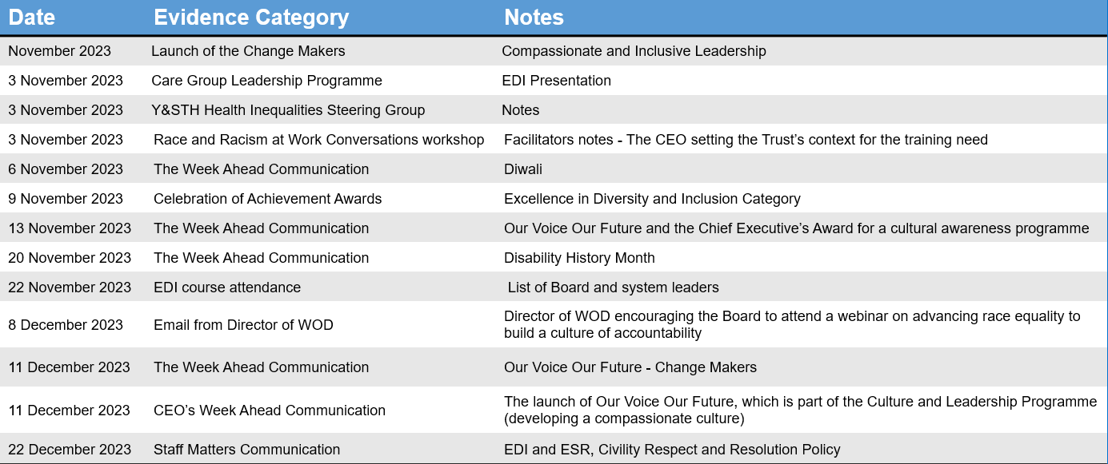 | 2 Achieving Activity | Head of Equality, Diversity and Inclusion
 | 3B: Board/Committee papers (including minutes) identify equality and health inequalities related impacts and risks and how they will be mitigated and managed | 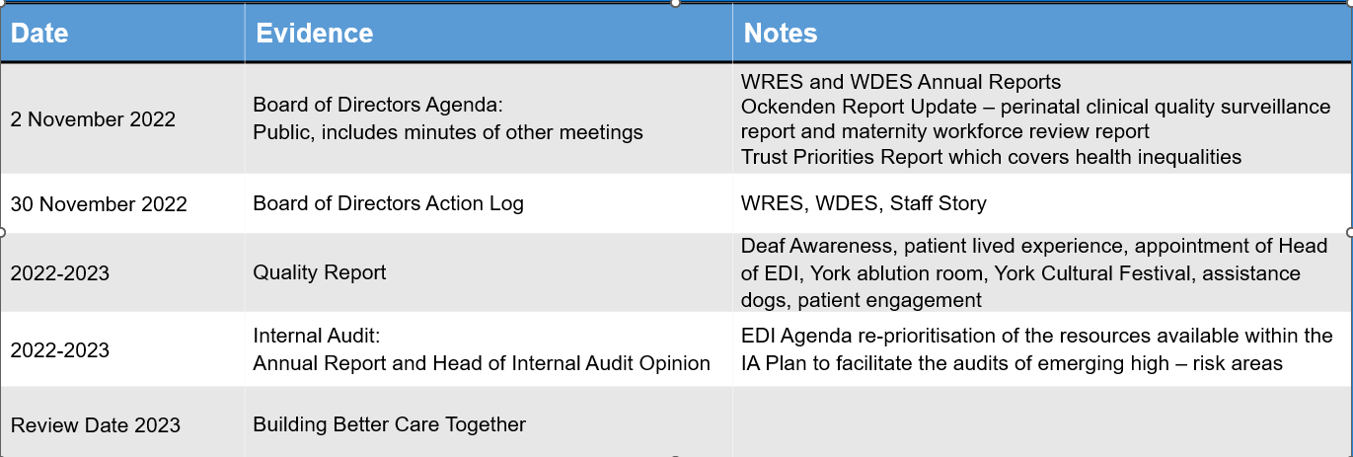  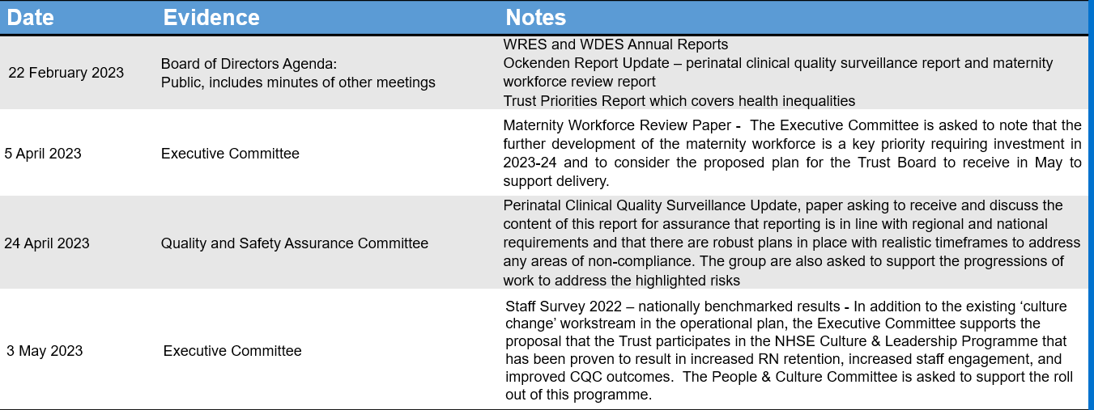  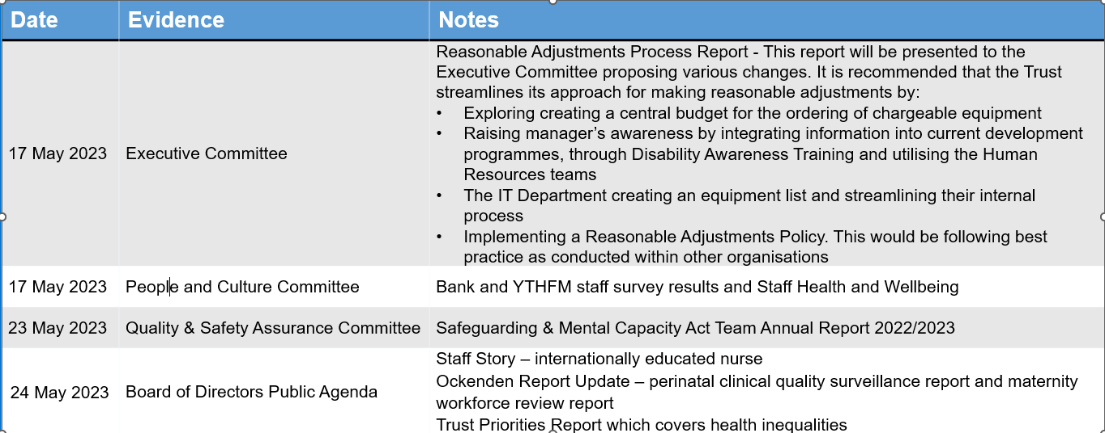  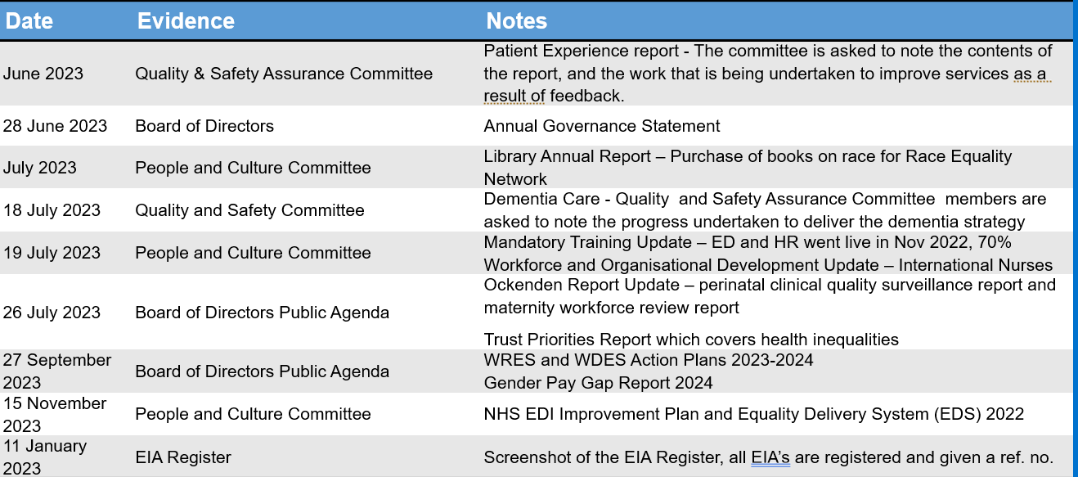 | 2 Achieving Activity | Head of Equality, Diversity and Inclusion
 | 3C: Board members and system leaders (Band 9 and VSM) ensure levers are in place to manage performance and monitor progress with staff and patients | 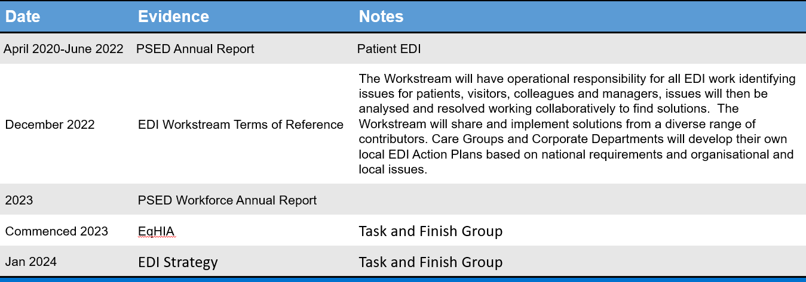  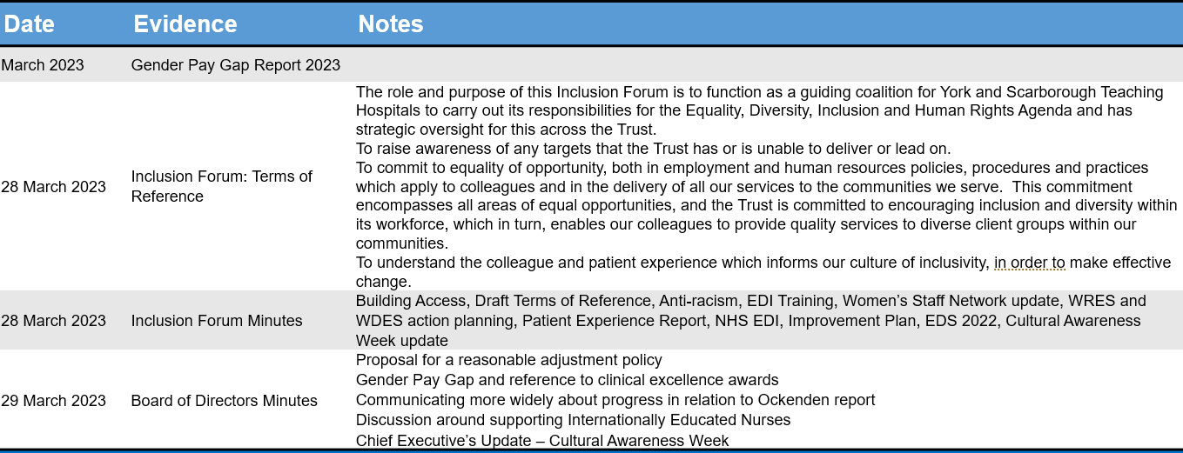  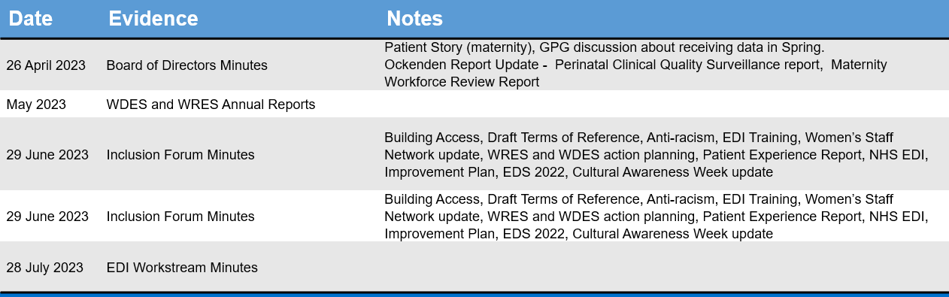  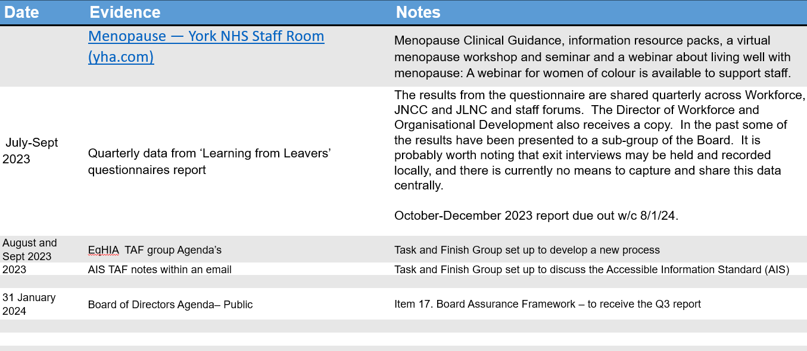  Gender Pay Gap Yearly Comparison  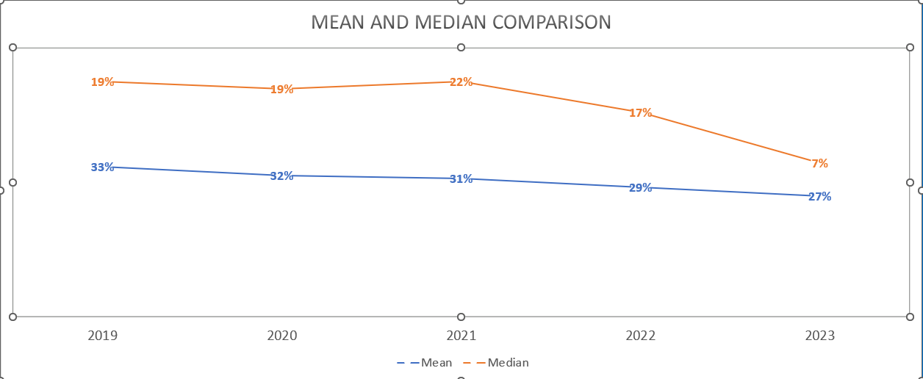  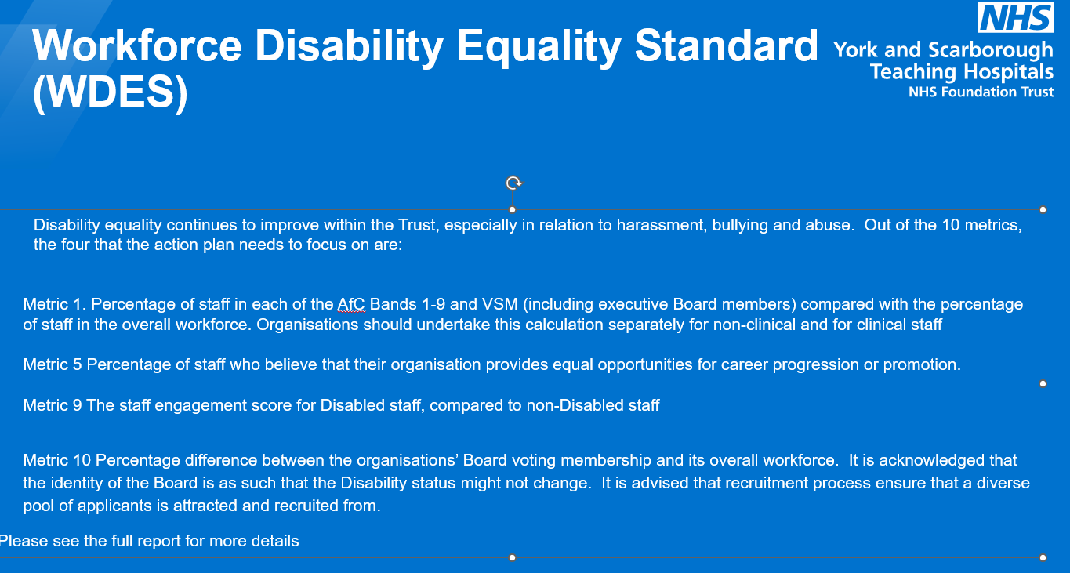  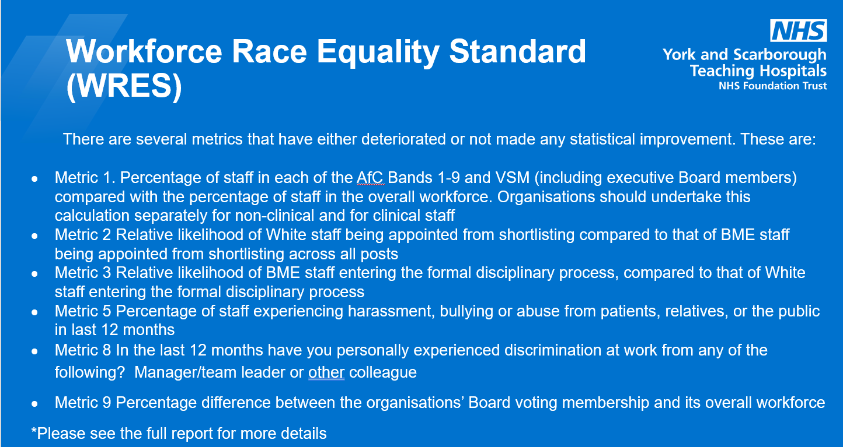  Equality, diversity and inclusion | York and Scarborough Teaching Hospitals (yorkhospitals.nhs.uk) | 2 Achieving Activity | Head of Equality, Diversity and Inclusion
Domain 3: Inclusive leadership overall rating |  |  | 6
Third-party involvement in Domain 3 rating and review
Trades Union Rep(s):  An RCN and Unite Representative | Independent Evaluator(s)/Peer Reviewer(s): Harrogate and District NHS Foundation Trust

EDS Organisation Rating (overall rating): 32

Organisation name(s): York and Scarborough Teaching Hospitals NHS Foundation Trust

Those who score under 8, adding all outcome scores in all domains, are rated Undeveloped

Those who score between 8 and 21, adding all outcome scores in all domains, are rated Developing

Those who score between 22 and 32, adding all outcome scores in all domains, are rated Achieving

Those who score 33, adding all outcome scores in all domains, are rated Excelling

EDS Action Plan
EDS Lead | Year(s) active
Head of Equality, Diversity and Inclusion | 2024
EDS Sponsor | Authorisation date
Director of Workforce and Organisational Development

Domain | Outcome | Objective | Action | Completion date
Domain 1: Commissioned or provided services | 1A: Patients (service users) have required levels of access to the service | To engage internally with services to discuss how the needs of patients can be met to ensure that:  - health inequalities are reduced  - discrimination is eliminated  - patients and staff are provided with appropriate tools. | Improve data collection across the Trust for protected characteristics and health inequalities. | Ongoing
 | 1B: Individual patients (service users) health needs are met | To engage with patients, carers, governors and local stakeholders and organisations, (including CCGs, social care, Healthwatch) to listen and understand the needs of our patients.  To achieve compliance with the Accessible Information Standard 2016 | Implement national reasonable adjustments recording and implement changes based on needs identified.  Increase number of leaflets and information available in Easy Read. | January 2025
 | 1C: When patients (service users) use the service, they are free from harm | To engage internally with services to discuss how the needs of patients can be met to ensure that:  - health inequalities are reduced  - discrimination is eliminated  - patients and staff are provided with appropriate tools. | Investigate making more training mandatory as appropriate. Regularly review Datix, PALS and other concerns and complaints to learn from information. | Ongoing
 | 1D: Patients (service users) report positive experiences of the service | To engage with patients, carers, governors and local stakeholders and organisations, (including CCGs, social care, Healthwatch) to listen and understand the needs of our patients. | Ensure Friends and Family Test (FFT) cards are available in a wide range of formats including Easy Read.  Encourage all services to proactively seek patient feedback. | January 2025  Ongoing

Domain | Outcome | Objective | Action | Completion date
Domain 2:  Workforce health and well-being | 2A: When at work, staff are provided with support to manage obesity, diabetes, asthma, COPD and mental health conditions | For staff to be provided with support in managing obesity, diabetes, asthma, COPD, and mental health conditions. | To continue to raise awareness of the current support that is available within the Trust, and ensure that all support can be accessed by all staff, by having a variety of communication sources used – e.g., internal comms, emails, posters, drop-in sessions etc.  More informative training for line managers, so that they are aware of what is on offer and can roll this out to their teams. A Line Manager Toolkit has been developed and will be rolled out in 2024. It includes information about the wellbeing offer and where to look to find all this information, which will result in managers being better equipped to support their teams, who can in turn, support themselves and others. | End of 2024 (ongoing and continuous piece of work).  Early 2024.
 | 2B: When at work, staff are free from abuse, harassment, bullying and physical violence from any source | Staf are free from abuse, harassment, bullying and physical violence at work. | Embed the new Civility, Respect and Resolution Policy, which was relaunched in December 2023, working in collaboration with trade union colleagues.  Embed the new Managing Violence and Aggression Policy, published in December 2023.  Roll out of training with new Safety Trainers and Educators in violence reduction to be offered to all staff, but with a phase 1 roll out targeting our high-risk areas. | December 2024  December 2024  Commencing March 2024
 | 2C: Staff have access to independent support and advice when suffering from stress, abuse, bullying harassment and physical violence from any source | That staff have access to independent support and advice when suffering from stress, abuse, bullying, harassment, and physical violence from any source. | A lot of the support is relatively new, so it needs to be embedded within the Trust to be able to measure efficacy.  More informative training for line managers, so that they are aware of what is on offer and can roll this out to their teams. A Line Manager Toolkit has been developed and will be rolled out in 2024. It includes information about the wellbeing offer and where to look to find this information, which will result in managers being better equipped to support their teams, who can in turn, support themselves and others.  Embed the new Civility, Respect and Resolution Policy, which was relaunched in December 2023, working in collaboration with trades union colleagues.  Development of Just and Learning Culture.  Develop further from the relaunch of the Fairness Champions in October 2023.  Launch of Our Voice Our Future.  Trust has signed up to the Sexual Safety at Work Charter. | Ongoing throughout 2024.  Early 2024.  Throughout 2024.  Throughout 2024.  Throughout 2024.  July 2024
 | 2D: Staff recommend the organisation as a place to work and receive treatment | Staff recommend the organisation as a place to work and receive treatment | The Trust has just commenced Our Voice, Our Future, a two-year continuous improvement programme focused developing an inclusive culture where colleagues want to come to work. The programme is following the NHSE Culture and Leadership Programme.  Development of a Just and Learning culture supported by the launch of Patient Safety Incident Response Framework, a new Conduct and Disciplinary Policy and the Civility, Respect and Resolution Policy. | Programme completion December 2025  May 2024

Domain | Outcome | Objective | Action | Completion date
Domain 3:  Inclusive leadership | 3A: Board members, system leaders (Band 9 and VSM) and those with line management responsibilities routinely demonstrate their understanding of, and commitment to, equality and health inequalities | To ensure that the Trust’s committees and the Board of Directors discuss equality and health inequalities in relation to employment and services and these are communicated to staff. | The Chair and CEO to ensure there is a notable profile of EDI on Board meetings.  Staff Network Executive Director Sponsors to formulate a programme for meeting with Committees and attending meetings.  All communication platforms to include EDI and HI topics where relevant. | June 2024
 | 3B: Board/Committee papers (including minutes) identify equality and health inequalities related impacts and risks and how they will be mitigated and managed | To ensure that committees and the Trust’s Board of Directors are assured the Trust is meeting its legal obligations in regards to assessing the impact and risk of any proposals being implemented. | EQIA updates are provided to the Trust’s Board of Directors on a quarterly basis to provide assurance of the Trust’s process. Progress to be included in the CEO’s report | July 2024
 | 3C: Board members and system leaders (Band 9 and VSM) ensure levers are in place to manage performance and monitor progress with staff and patients | Increase the senior leadership Team’s involvement in supporting and communicating information about the menopause support available to staff. | H&WB Lead to work with the Senior Leadership Team to enable them to support and communicate about menopause campaigns and information. For example:  - Menopause Friendly Accreditation  - Menopause Guidance resources | August 2024

Patient Equality Team
NHS England and NHS Improvement
england.eandhi@nhs.net

Note that since the objectives were written the CCG had become the Integrated Care Board including York Place.

