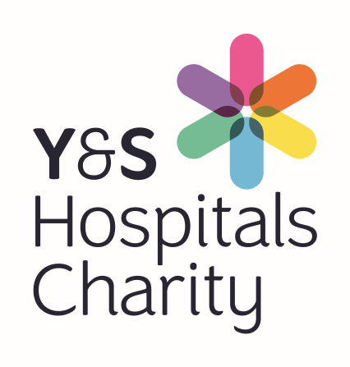
Ref no:

Reg. Charity 1054527

Charity Request to Expend Form

Requestor Name:

Ward/Dept: Date of Request:

Fund Name: Fund No:
(Leave blank if unknown)
Please complete all areas of the form
Description/ Specification of Purchase  (Attach separate sheet if needed) : |  | Cost including VAT
Total Charitable Cost |  | £

Revenue Cost Implications (Maintenance / Training Etc.)

Give details:
Explain how patients will benefit:

Please complete the other side
The purchase of equipment above £1,000 has to go through MERG. Charitable fund authorisation should be received first before applying to MERG to ensure there is funding available.
MERG Approval Required?
If your application will benefit more than one ward, have all wards been consulted so they are aware of your funding application and they are supportive of your request?

Are the League of Friends or Other Outside Bodies involved in the Purchase?

If Yes, please attach a letter of funding confirmation from the Funding Body concerned

Requestor Authorisation  Name:  Signature:  Date: | Line Manager Authorisation  Name:  Signature:  Date:
Fund holder Authorisation Fund number:

As fund holder I have considered this request and confirm it meets the Charitable Expend Tests?
(Detailed in section 3.2 of Charity Expenditure Policy)

- The public perception test Y/N

- The patient benefit test Y/N

- The additionality test Y/N

Name:

Signature: Date:

Email the completed form to:
yhs-tr.charity.finance@nhs.net and yhs-tr.charity.fundraising@nhs.net

Charitable Funds, Financial Services, Tribune House, Tribune Way, Clifton Moor, York, YO30 4RY

